**Digital Image Processing Project Report**

Project 1: Image Enhancement

May 10, 2013

Contents

1. Experiment Objectives - 2 -

2. Involved Principles - 2 -

2.1 Histogram Equalization - 2 -

2.2 Mean Filtering & Median Filtering - 3 -

2.3 Sharpening Spatial Filtering - 3 -

2.4 Color Image Processing - 3 -

3. Experiment Procedures - 4 -

3.1 Histogram Equalization - 4 -

3.2 Mean Filtering - 6 -

3.3 Median Filtering - 7 -

3.4 Horizontal Stripes Elimination - 8 -

3.5 Color Image Processing - 9 -

4. Results - 10 -

4.1 Image 1: 1.jpg - 10 -

4.2 Image 2: 2.jpg - 11 -

4.3 Image 3: LenaRGBLow1.bmp - 11 -

4.4 Image 4: LenaRGBLow2.bmp - 12 -

5. Summary - 12 -

# 1. Experiment Objectives

There are 4 different images, and each has special extent of defects. So in this project, we want to enhance different images by Spatial or Frequency methods. The project mainly consists of 4 parts:

(1) Write a program to load the input image and show it.

(2) Show the histogram of the input image.

(3) Enhance the input image.

(4) Show the enhanced image and its histogram.

# 2. Involved Principles

## 2.1 Histogram Equalization

The histogram of a digital image with gray levels from 0 to L-1 is a discrete function. The histogram of an image shows us the distribution of grey levels in the image. It is useful in image processing, especially in enhancement and segmentation.

Histogram equalization’s basic idea is to find a map T(r) such that the histogram of the modified (equalized) image is flat (uniform). For discrete value we deal with probabilities and summations instead of probability density functions and integrals.



Where *n* is the total number of pixels, *nk* is the number of pixels that have gray level *rk,, l* is the total number of possible gray levels*. pr*(*rk*)is the probability of occurrence of gray level *rk..*



## 2.2 Mean Filtering & Median Filtering

Order statistics filters are nonlinear spatial filters whose response is based on ordering the pixels in the area of filter. Some typical operations include:

* **Min:** Set the pixel value to the minimum in the neighbourhood
* **Max:** Set the pixel value to the maximum in the neighbourhood
* **Median:** The median value of a set of numbers is the midpoint value in that set (e.g. for a 3*3 neighbourhood, with grey level (10,20,20,20,15,20,20,25,100), then we can order them in (10,15,20,20,20,20,20,25,100),20 is the median. Sometimes the median works better than the average.

These two filters are often used to remove noise from images. Sometimes a median filter works better than an averaging filter. So median filter is particularly effective in the presence of impulse noise, which is also called salt-and-pepper noise. In this project, I used 3*3 and 5*5 median and mean filters to do filtering.

## 2.3 Sharpening Spatial Filtering

Previously we have looked at smoothing filters which remove fine detail

Sharpening spatial filters seek to highlight fine detail:

* Remove blurring from images
* Highlight edges

Averaging is analogous to integration and causes blurring, so differentiation is expected to have opposite results and sharpen an image. The filter used in the project is aiming to eliminate the horizontal stripes of the first image, which is just like the form as below:

## 2.4 Color Image Processing

This part is mainly about the processing of color images, which are commonly 24-bit for 8-bit each channel.

A full color image has a vector at each pixel. For colour images, these vectors each have 3 or 4 components. There are two Categories to process vectorial images:

* First Category:

Process each component image individually

Form a composite processed color image

* Second Category:

Work with color pixel directly

Color pixels are vectors

When I deal with color image by using Sharpening Spatial, Mean and Median filters, it is reasonable to use the First Category, but with Histogram Equalization, it is unwise. A more logical approach is to spread the color intensities uniformly and leave the colors themselves (e.g Hue) unchanged.

# 3. Experiment Procedures

## 3.1 Histogram Equalization

(1) Gray Image

We can first statistics the gray value distribution, then plot histogram according to the data such as “2.jpg”.

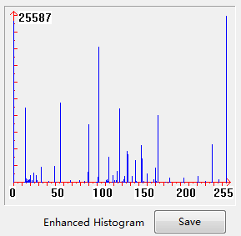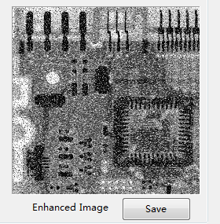

Fig. 3.1 Enhanced Image and Histogram after Equalization of “2.jpg”

(2) Color Image

In the project, Histogram Equalization is mainly used to deal with color image to do contrast enhancement, such as “LenaRGBLow1.bmp” and “LenaRGBLow2.bmp”.

The method is to transfer RGB to HIS, and then do equalization with “Intensity” channel with Hue and Saturation unchanged.

The graying formula is gray = (R*299 + G*587 + B*114 + 500) / 1000.

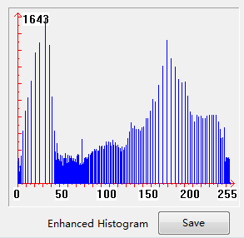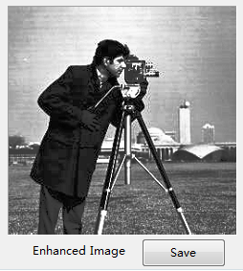Fig. 3.2 Enhanced Image and Histogram after Equalization of “1.jpg”

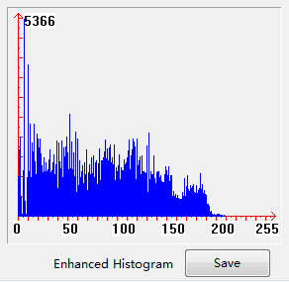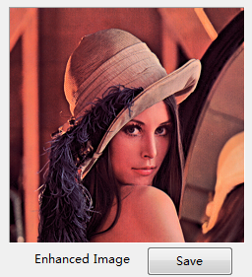 Fig. 3.3 Enhanced Image and Histogram after Equalization of “LenaRGBLow1.bmp”

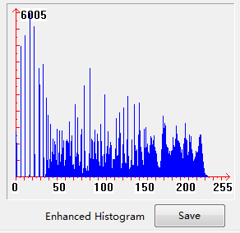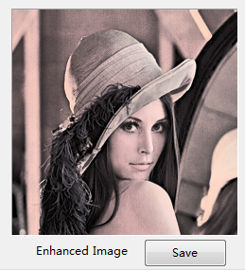Fig. 3.4 Enhanced Image and Histogram after Equalization of “LenaRGBLow1.bmp”

## 3.2 Mean Filtering

(1) Gray Image

First getting pixel values of 8 neighbourhoods for 3*3 or 24 neighbourhoods for 5*5 mean filter, then get mean value of them to act as the filtered value of the pixel.

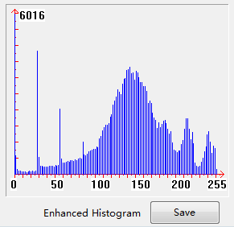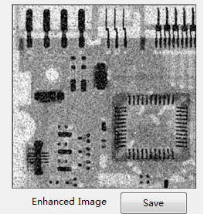

Fig. 3.5 Mean-filtered(3*3) Image and Histogram of “2.jpg”

(2) Color Image

The method is to do mean filtering with each of three channels, and then combine filtered values.

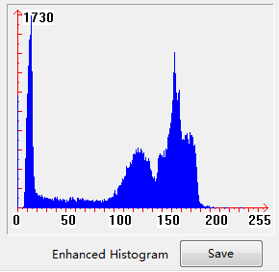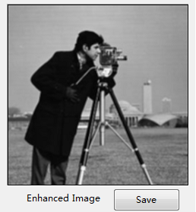Fig. 3.6 Mean-filtered(3*3) Image and Histogram of “1.jpg”

## 3.3 Median Filtering

(1) Gray Image

First getting pixel values of 8 neighbourhoods for 3*3 or 24 neighbourhoods for 5*5 mean filter, then get median value of them to act as the filtered value of the pixel.

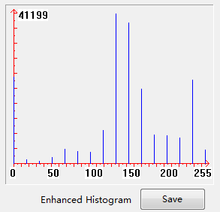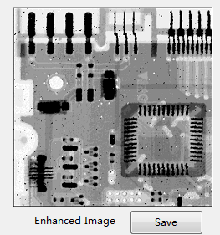Fig. 3.7 Median -filtered(3*3) Image and Histogram of “2.jpg”

(2) Color Image

The method is to do median filtering with each of three channels, and then combine filtered values.

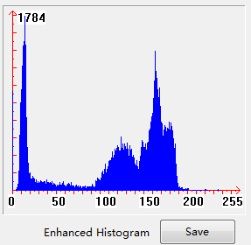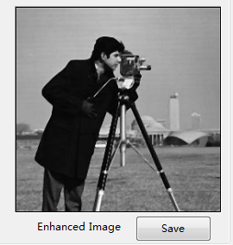

Fig. 3.8 Median -filtered(3*3) Image and Histogram of “1.jpg”

## 3.4 Horizontal Stripes Elimination

The method is using a convolution operator to convolve with initial image to do elimination, the operator has maximum value along the vertical direction. The operator used here is

As with color image, we first split it into R, G and B components. Then do elimination with each of them, finally combine them to a new color image. As with gray image, we can do this directly.

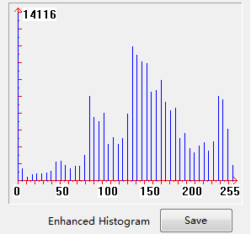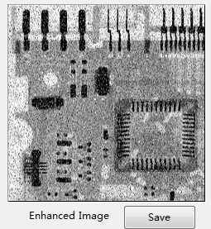Fig. 3.9 Stripe Eliminated Image and Histogram of “2.jpg”

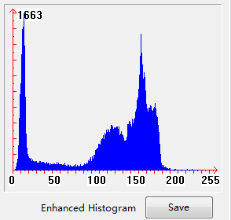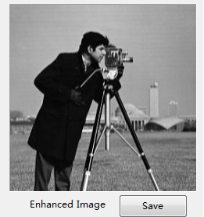Fig. 3.10 Stripe Eliminated Image and Histogram of “1.jpg”

## 3.5 Color Image Processing

In histogram equalization, we need to do equalization with Intensity component separately, so we need to transfer RGB to HSV firstly and then get I component. After finishing equalization with Intensity, we should transfer HSV to RGB and get a color image which is the same with initial image.

Here HSV color space is almost the same with HSI color space, so we use HSV instead of HSI.

(1) RGB to HSV

|  |
| --- |
| //RGB空间转到HSV空间  void Chw1Dlg::RGBToHSV(BYTE *pHue, BYTE *pSaturation, BYTE *pValue, BYTE cRed, BYTE cGreen, BYTE cBlue);  //计算HSI色调值  int GetHueFromRGB(int nAngle, int nRed, int nGreen, int nBlue); |

(2) HSV to RGB

|  |
| --- |
| //HSV 模式转换成RGB 模式  void Chw1Dlg::HSVToRGB(BYTE *pRed, BYTE *pGreen, BYTE *pBlue, BYTE cHue, BYTE cSaturation, BYTE cValue); |

(3) Split RGB Image

|  |
| --- |
| //对图象进行取RGB模式中红分量处理  void GetRedOfTrueColor(ATL::CImage *pNewImage, ATL::CImage *pImage);  //对图象进行取RGB模式中绿分量处理  void GetGreenOfTrueColor(ATL::CImage *pNewImage, ATL::CImage *pImage);  //对图象进行取RGB模式中蓝分量处理  void GetBlueOfTrueColor(ATL::CImage *pNewImage, ATL::CImage *pImage); |

# 4. Results

The defects and methods of enhancement are listed in the chart below:

|  |  |  |
| --- | --- | --- |
| Image | Defects | Methods of Enhancement |
| 1.jpg | **Horizontal Stripes** | **Sharpening Spatial Filtering** |
| 2.jpg | **Pepper-salt Noises** | **Mean and Median Filtering** |
| LenaRGBLow1.bmp | **Low Degree of Contrast** | **Histogram Equalization** |
| LenaRGBLow2.bmp |

## 4.1 Image 1: 1.jpg

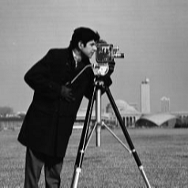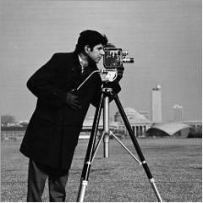

## 4.2 Image 2: 2.jpg

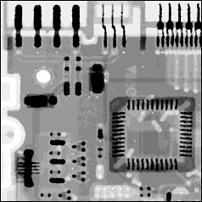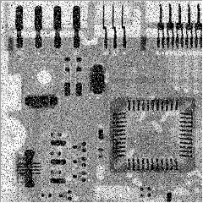

## 4.3 Image 3: LenaRGBLow1.bmp

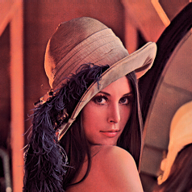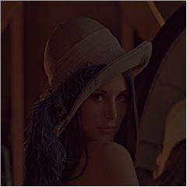

## 4.4 Image 4: LenaRGBLow2.bmp

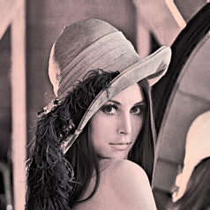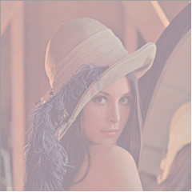

# 5. Summary

(1) There are many different image processing methods, such as filtering, histogram equalization, one-order or two-order convolution operation and so on, we should choose proper methods according to specific problems, so that we can get perfect results of enhancement.

(2) From this project I learn much more knowledge about DIP than in class lessons, and I have tried many and many methods to solve reading image, processing image , transferring image and so many other problems. During the process, we have faced many difficulties, but I have resolved and overcome them to get relative good results as shown in the report.